**EXPERIMENT No.6**

**DEMONSTRATION OF THE WORKING OF**

**REFRIGERATION CYCLE**

**Introduction:**

* • Definition:The term refrigeration means cooling a space, substance or system to lower  
  and/or maintain its temperature below the ambient one (while the removed  
  heat is rejected at a higher temperature). In other words, refrigeration is  
  artificial (human-made)  
  cooling. A reverse thermodynamic cycle whereby heat is transferred from a body with a lower temperature to a body with a higher temperature owing to the expenditure of work. Refrigeration cycles are used in refrigerating machines and in gas refrigerators.

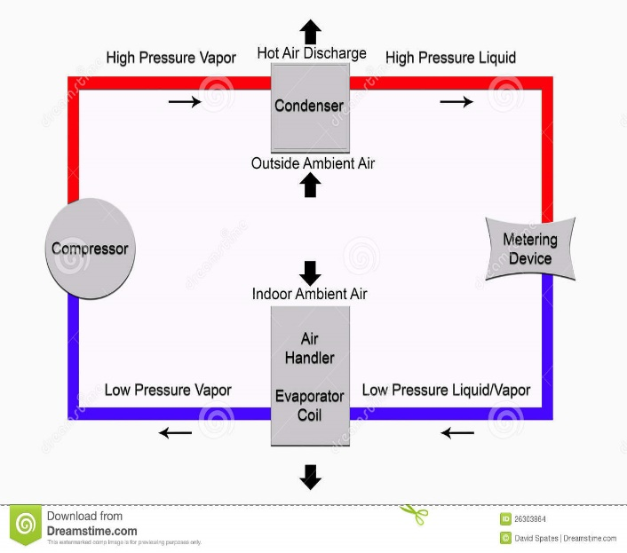

* “It is a well-known fact that heat flows in the direction of decreasing temperature as from a high temperature region to a low temperature region.”
* But the reverse process (heat transfer from low to high temperature) cannot occur by itself (Clausius Definition of Second Law).
* This process requires a special device called **Refrigerator.**

**Part Lists:**

Figure 1:Diagram of Refrigeration cycle

The refrigeration cycle contains four major components:

* **Compressor**
* **Condenser**
* **Expansion device**
* **Evaporator**
* Refrigerant (Dichlorofluoromethane) remains piped between these four parts and is contained in the refrigerant loop. The refrigerant begins as a cool vapor and heads to the Compressor.

**Types Of Compressor:**The four most common types of air compressors are:  
• Rotary Screw Compressor.  
• Reciprocating Air Compressor.  
• Axial Compressor.  
• Centrifugal Compressor.

**Explanation:**

**Refrigeration Cycle Consists of following process**

* Compression
* Condensation
* Expansion
* Evaporation

**Working Explanation:**

**Compression:**

* In this stage, the refrigerant enters the compressor as a gas under low pressure and having a low temperature. Then, the refrigerant is compressed adiabatically. So, the fluid leaves the compressor under high pressure and with a high temperature.

**Condensation:**

* The high pressure, high temperature gas released heat energy and condenses inside the **condenser** portion of the system. The condenser is in contact with the hot reservoir of the refrigeration system.
* The gas releases heat into the hot reservoir because of the external work added to the gas. The refrigerant leaves as a high-pressure liquid.

**Expansion:**

* The liquid refrigerant is pushed through a expansion valve, which causes it to expand. As a result, the refrigerant now has low pressure and lower temperature, while still in the liquid phase.
* The throttling valve can be either a thin slit or some sort of plug with holes in it. When the refrigerant is forced through the throttle, its pressure is reduced, causing the liquid to expand.

**Evaporation:**

* 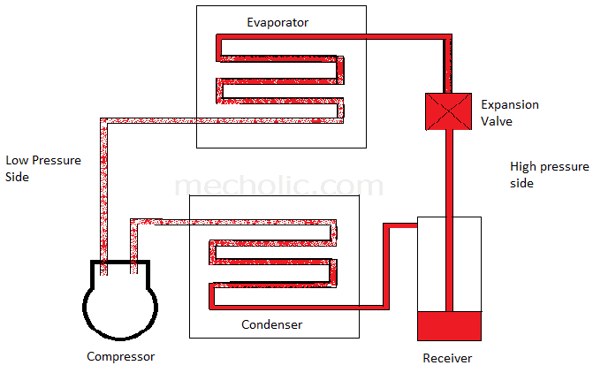The low pressure, low temperature refrigerant enters the evaporator, which is in contact with the cold reservoir. Because a low pressure is maintained, the refrigerant is able to boil at a low temperature. So, the liquid absorbs heat from the cold reservoir and evaporates. The refrigerant leaves the evaporator as a low temperature, low pressure gas and is taken into the compressor again.

Figure 2:Working Diagram of Refrigeration Cycle

**Working Diagram:**

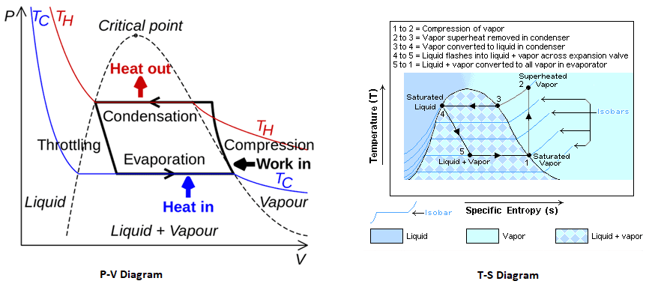

Figure 3:Working Diagram P-V and T-S of Refrigeration Cycle

**General Theory:**

* High temperature takes place at Condenser.
* Low temperature takes place at Evaporator.
* Electricity is provided to Compressor, which is the main part of Refrigerator. Inside the compressor, electrical energy is converted into mechanical energy.
* Expansion valve is used to decrease the pressure and temperature of incoming liquid at least atmospheric temperature. If Expansion valve is not used, the heat will transfer from evaporator to room.
* Cooling takes place around evaporator.
* Heating takes place around condenser.
* Refrigerant delivers only cooling.
* A.C supplies both cooling and heating.
* Temperature is same at inlet and outlet of condenser.

**Latent Heat:**

* The amount of energy absorbed or released during a phase-change process is called the **Latent heat** and is greater than 100`C for a liquid like water.

**Sensible Heat:**

* 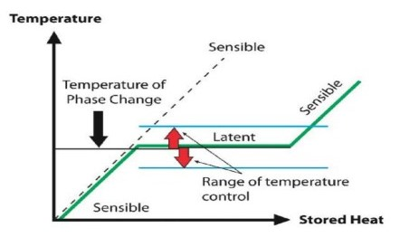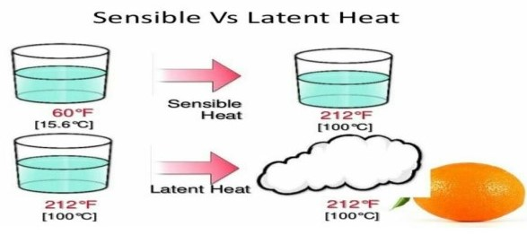The amount of heat that is before the boiling point of a liquid and raised the temperature before reaching the boiling point is known as **Sensible heat.**

**APPLICATIONS:**

The applications are given below in following:

* Domestic Refrigerator
* Water Cooler
* Air Conditioner
* Ice plant
* Cold Storage
* For chilling the oil to remove wax in oil refineries
* For preservation of tablets and medicines in Pharmaceutical industry
* For the preservation of blood tissues.